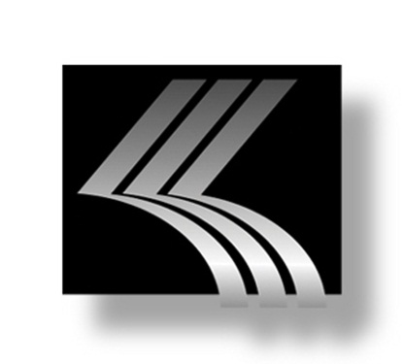
Kenwal Steel
Background

Kenwal Steel Corp. is one of the largest flat-rolled steel distributors in North America with annual revenue of about $900 million. The company’s six locations total 1.2 million square feet, including three service center locations in Dearborn, Michigan; Burns Harbor, Indiana; and Lebanon, Tennessee. Kenwal employs about 450 across its service locations.
Kenwal is known for excelling at difficult, deep draw applications where part severity and metallurgical input are fused together to establish proper mill practices for specific steel production. Its strong relationships with top-tier steel mills, combined with Kenwal’s deep technical and metallurgical bench ensure the company’s steel inventories, are always be of exceptional quality. Kenwal’s inventories include hot rolled, hot rolled pickled and oiled, cold rolled, galvanized, electro-galvanized, galvanealed and aluminized in both low carbon and high carbon strength low allow grades.
Founded by Sol Eisenberg in Detroit in 1947, Kenwal Steel is a family owned and operated business. Sol’s elder son, Kenneth, joined the business in the 1960s, leading the way to continued growth and operational excellence. Under Kenneth’s leadership, Kenwal has grown to be a full service steel processing company that serves customers in the automotive, electronics, appliance and tubing industries, as well as other major equipment manufacturers and steel related businesses. Stephen Eisenberg, Kenneth’s son, joined the company in the 1990s and now oversees more than a half million tons of production each year.
Kenwal continues to expand its services and market footprint to serve the ever changing needs of its customers. For more information about Kenwal Steel, please visit kenwal.com.

